IS 436 - Structured System Analysis & Design

Deliverable 3 - Process Modeling

Team Members:

Adam Afilaka: Developer/Programmer (aafilak1@umbc.edu)

Ashley Braun: Business Analyst/Legal Compliance/Project Manager (410-991-1496; abraun1@umbc.edu)

Zaid Islam: Cyber Security Engineer (240-688-5964) (zislam1@umbc.edu)

Rithika Sayini: Researcher/Programmer (rithika1@umbc.edu)

Shanese Scott: Database Administrator (443-760-1459; scsh1@umbc.edu)

Xin Zheng: Quality Assurance(443-931-9403; xinz1@umbc.edu)

November 7, 2019

**Level-0**

* **External Entities**
  + Patient: a person wearing the EMR and will be monitored for any health risk and produce data to the EMR.
  + EMR: a wearable device that shall be used to record a patient EMR data. The device is used mainly for the collection of data and to transmit processed data to proper end data storage
  + Doctor: a person who EMR data is reported to and has access to all data storages to analyze information from data to diagnose the patient.
* **Processes**:
  + Recording of Data Activity: Data from the activity of the Patient is being recorded by the EMR technology. It is constantly being updated as the Patient goes wearing the device.
  + Analysis of Updating Data: Data is going through predetermined sets constantly and being recorded for the status of behavior over time. Any data that alerts and predetermined sets will send out an alert to follow processes set for that data.
  + Sorting of Patient EMR Records: Patient data of activity is sorted into the correct storage place to be requested by a Doctor if ever needed for the desired patient.
  + Alert of Potential Adverse Event: Data is processed to follow protocols to transmit data to a doctor or proper persons of interest who will require the data from the EMR.
  + Transmission of Alert to Data Storages: Protocols to sort and organize data to be transmitted to proper Data storages to be analyzed.
  + Compiled Data into User Interface: During the data collected inside data storage to an application Doctor can use to visualize the information sent by the EMR device.
* **Data Storages**
  + Medical Recording Storage: Data stored to be used by the Doctor user interface for past activity collected by the EMR.
  + Doctor EMR Data Storage: Data processed that alerted the system of possible health risk or activity that required quick doctor attention for quicker diagnosis.

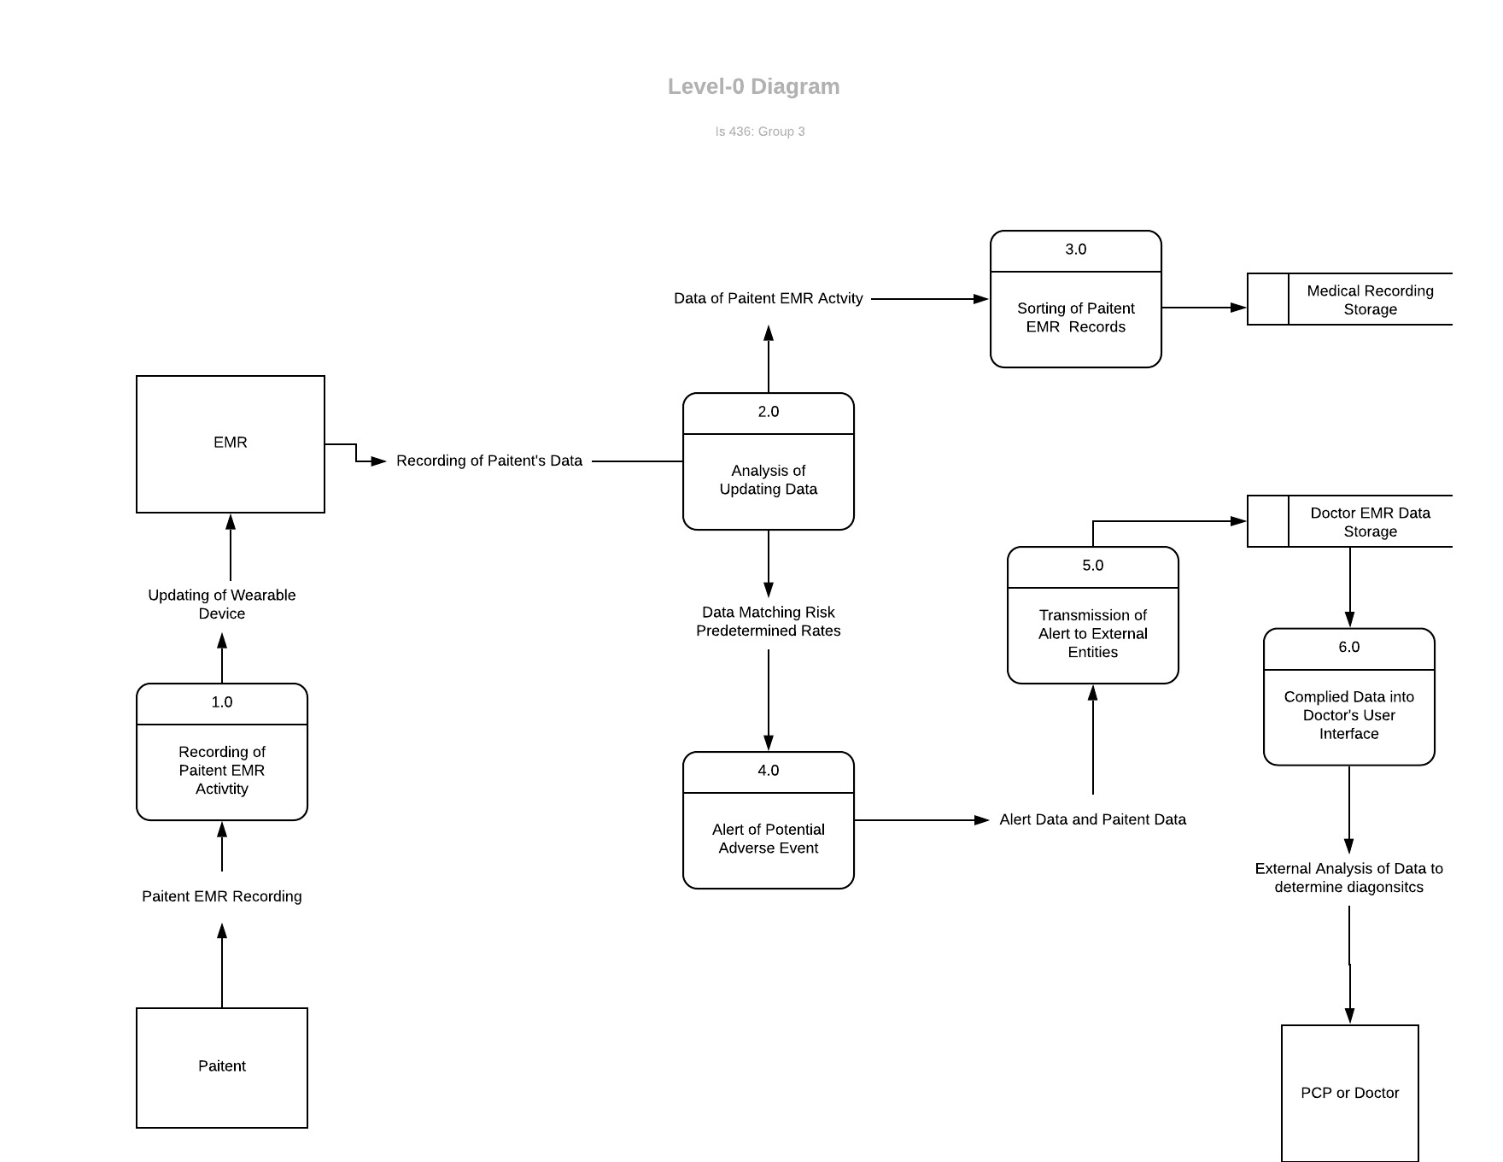

**Process-1**

* **External Entities**
  + Patient: Monitored for any changes in vitals
  + EMR: a wearable device that shall be used to record a patient EMR data. The device is used mainly for the collection of data and to transmit processed data to proper end data storage
* **Processes**:
  + EMR device sounds an alert: EMR device will sound or display an alert when a patient’s vitals change
  + Recording of patient EMR activity: EMR is constantly recording and analyzing patterns in the patient’s activity.
  + The device waits for patient response: If the EMR device detects that there may be an issue it will request the patient to respond to the alert.
  + EMR device records response: If there is no issue the patient can dismiss the alert.
  + Patient profile updated: New data will be updated in real-time and be visible on the app for future reference
* **Data Storages**
  + EMR database storage: Data that includes a collection of all activity monitored on the device.

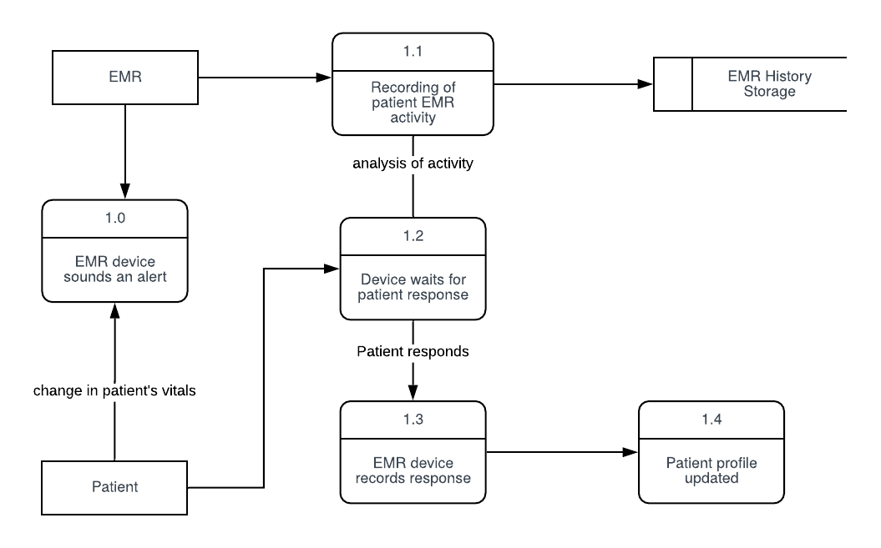

**Process-2**

* + Analysis of Updating Data: Data is going through predetermined sets constantly and being recorded for the status of behavior over time. Any data that alerts and predetermined sets will send out an alert to follow processes set for that data.
* **External Entities**
  + EMR: receipt of patient vitals and pertinent medical data.
* **Processes**:
  + EMR processes vitals received: patient’s vitals are checked based on predetermined sets. If vitals are within normal range, data is transferred to recycled EMR data storage for temporary storage.
  + Data Analysis: data examined on the basis of predetermined sets and alert data.
  + Recording Data to EMR: Alert data recorded to EMR and alert sent to patient wearable EMR. Other predetermined sets will prompt recording to EMR and further monitoring for behavior status to determine other processes. Some data may require gathering of vitals over specified periods of time or transmission of specific data to certain providers.
  + Alert Sent to Patient Device: patient receives proper alert for action.
  + Updating EMR: EMR updated based on high alert data, predetermined sets, or manual entry by healthcare providers.
* **Data Storages**
  + EMR Temporary database storage: Data that is filtered out of the system but retained for a short period of time (in the event it becomes relevant at a later, proximate time).
  + EMR database storage: retaining of all a patient’s relevant medical data and vitals.

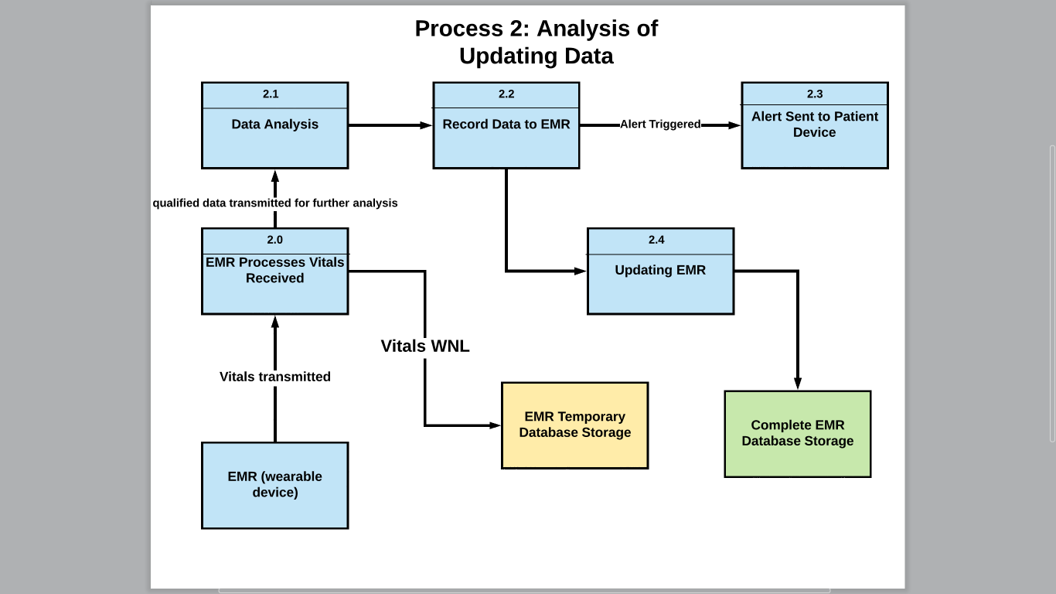

**Process-3**

Patient data of activity is sorted into the correct storage place to be requested by a Doctor if ever needed for the desired patient.

* **External Entities:**
  + EMR: provides the data of electronic vital signs and medical records from patient
* **Processes**:
  + Capture EMR records' data fields: The data fields of patient’s medical records and vital signs are captured. The data fields that need to accurately captured include medical records’ document type, provider, data, etc.
  + Section and subsection EMR records: Arrange and category the medical records into sections and subsections. Some specific record will have its own section. For example, GP record will be sectioned by itself. Then, Chronologically sorting the documents within the sections by date range(level-2).
  + Delete duplicate records: Check the sectioned EMR records to see if there is any duplicated records. If there are any duplicate records, it’ll be removed from the section and stored as a separate file to the medical recording storage(level-2).
  + Create the index of sorted EMR records: After EMR records are sorted, give index to the file by giving them page numbers. Page numbering starts from “Page 1” and continuously increases throughout the entire medical file.
  + Update patient EMR records: update patient’s sorted and indexed medical records to the medical recording storage. It’ll be ready for future request from doctors.
* **Data Storages:**
  + Medical Recording Storage: contains the data of the medical records from past EMR activity. And, provides the access to the doctors of these medical records through the user interface.

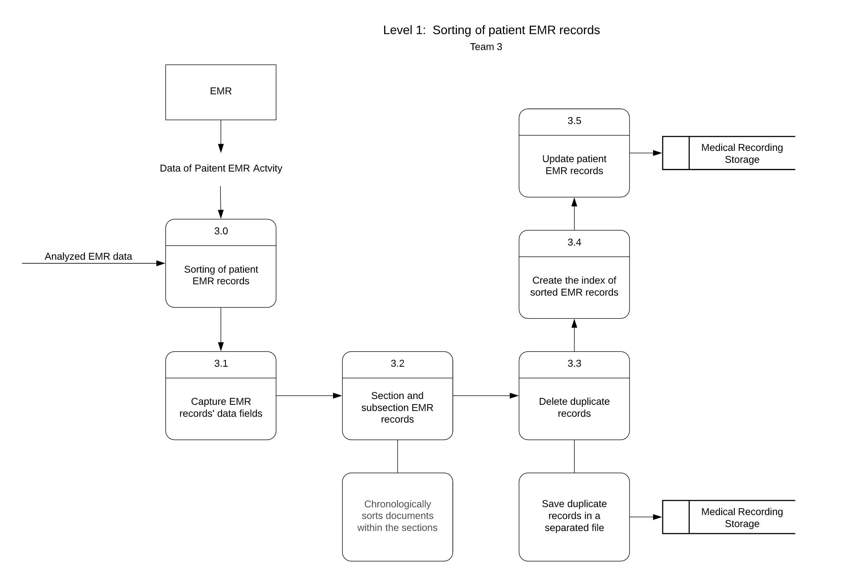

**Process - 4**

Alert of potential Adverse Event **-** Device is implemented with an alert system that will notify the patient when a fatal change in homeostasis has occured due to trauma or adverse event.

* **External Entities:**
  + EMR Wearable Device: Device detects and records changes in vital signs and homeostasis to determine severity of situation in order to alert medical personnel.
* **Processes:**
  + 4.0- EMR Device Detects Change in Homeostasis: The wearable device detects changes in heart rate, blood pressure, breathing rate, hormone levels, and other vitals.
  + 4.1 - Recording of Patient EMR activity - The current vitals are updated in real time and stored in the EMR History Storage.
  + 4.2 - Analysis of Severity of Situation - If the vital signs are drastically different from patient’s normal homeostasis, the application will assess whether the user needs emergency medical attention.
  + 4.3 - Device Pauses for Patient Responsiveness - In special cases, the patient must be responsive to the device in order for medical personnel to arrive at the scene of the adverse event. In this case, the device will allow ten seconds for the patient to indicate whether they are responsive or not.
  + 4.4 - Device Alerts Emergency Medical Personnel - If the potential adverse event is deemed severe, or even life threatening, or if the patient is not responsive after 10 seconds, the application will alert emergency medical personnel. The patient’s PCP is also alerted of the current emergency event so that they are prepared to provide proper diagnosis.
* **Data Storages**
  + EMR History Storage - Contains past EMR activity as well as Emergency Situation activity. Vitals during an emergency situation, as well as length of response time if there is one will be recorded for future reference.

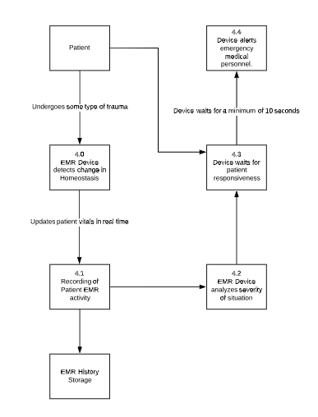

**Process 5 - Transmission Alert to External Entities**

**External Entities**

EMR Data - The data from the patient that is used to track the well being of the patient

**Processes**

* Prioritize the most recent alert- There are many variables being tracked but the variable causing the alert should be prioritized
* Organize alerts - Organize alerts happening in the same time frame together. The possibility of one alert leading to another is possible

- Conversion of Alert to Radio Signals- Emergency service providers usually use emergency radio channels in order to receive notifications when phone lines are down

- Conversion of Alert to Nearest Hospitals - In an emergency situation, the nearest hospitals should be notified in advance so they have time to prepare accordingly

**Data Storages**

EMR History Storage-

Doctor EMR Data Storage - Used by the doctor to see all the EMR data from the patient in order to enhance diagnostic

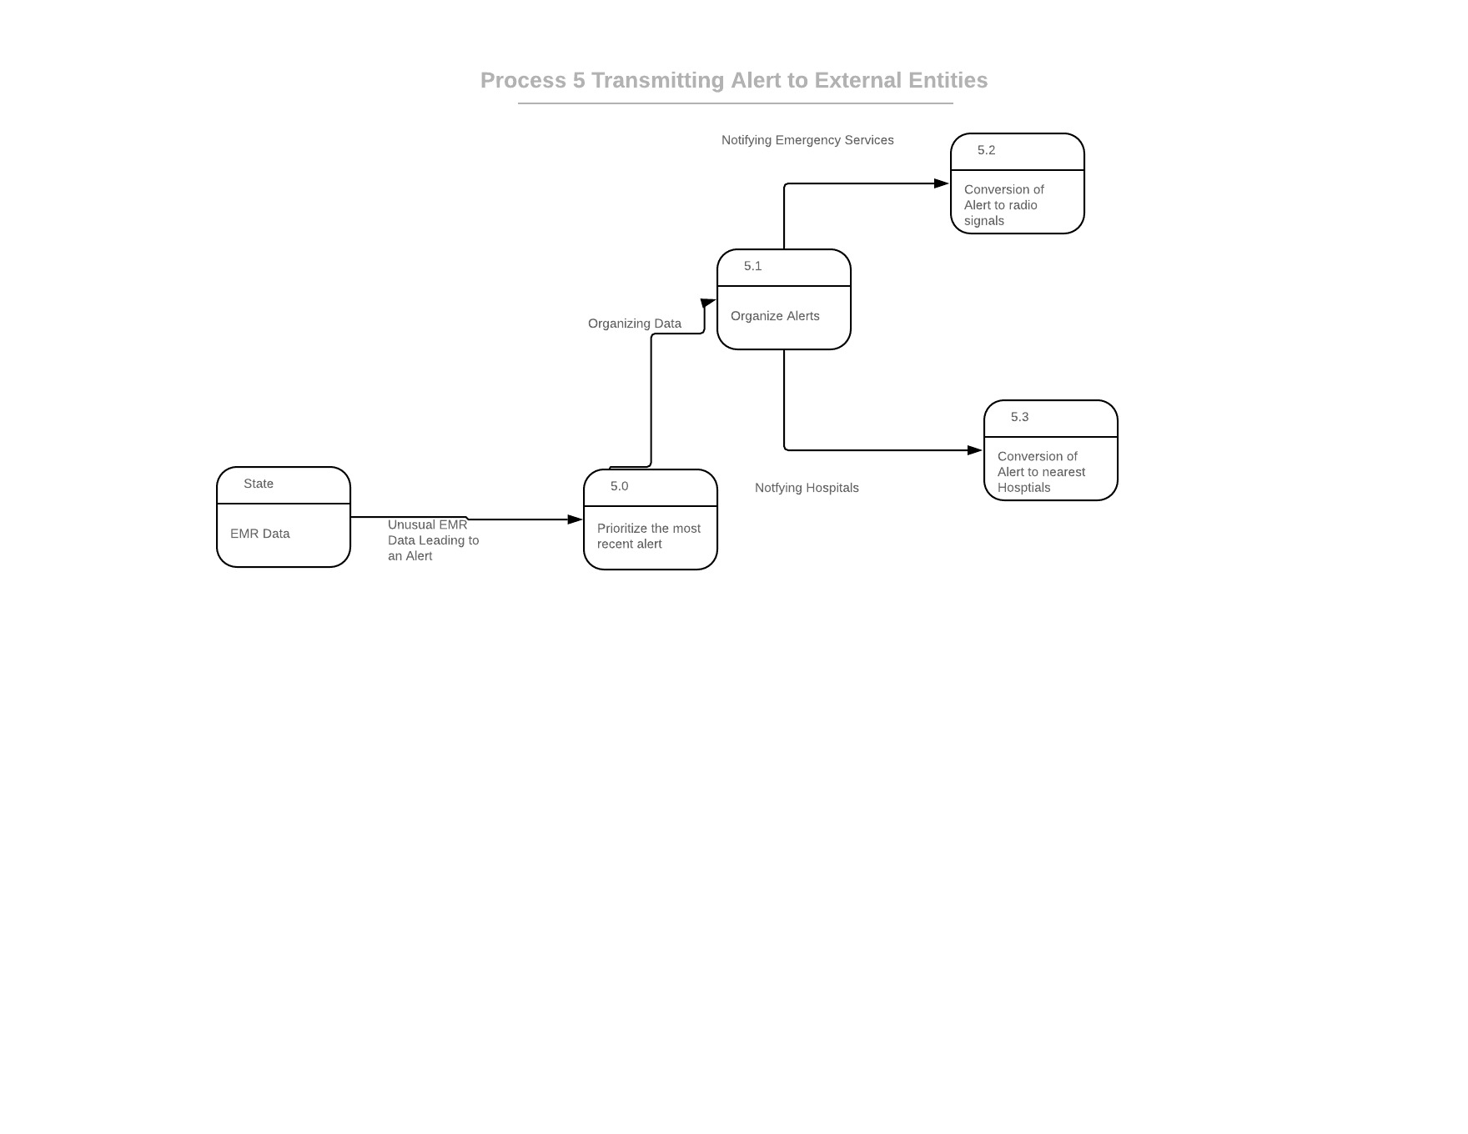

**Process-6**

* **Storages**
  + Doctor EMR Data Storage: Data processed that alerted the system of possible health risk or activity that required quick doctor attention for quicker diagnosis.
* Process
  + Extraction of Paitent's Data from EMR Data Storage: Collecting and sorting the data from the EMR database to be specified protocol for a patient
  + Authorization of Access to Patient's Data: Security protocol to ensure access is given only to selected end-user
  + Transmission of Data to Selected Doctor or PCP Software: Data turned into information based on UI design to eligibility and user friendly for immediate analysis.
  + Compiled Data into Doctor's User Interface: Information is displayed in Doctor’s UI
* **External Entities**
  + Doctor or PCP

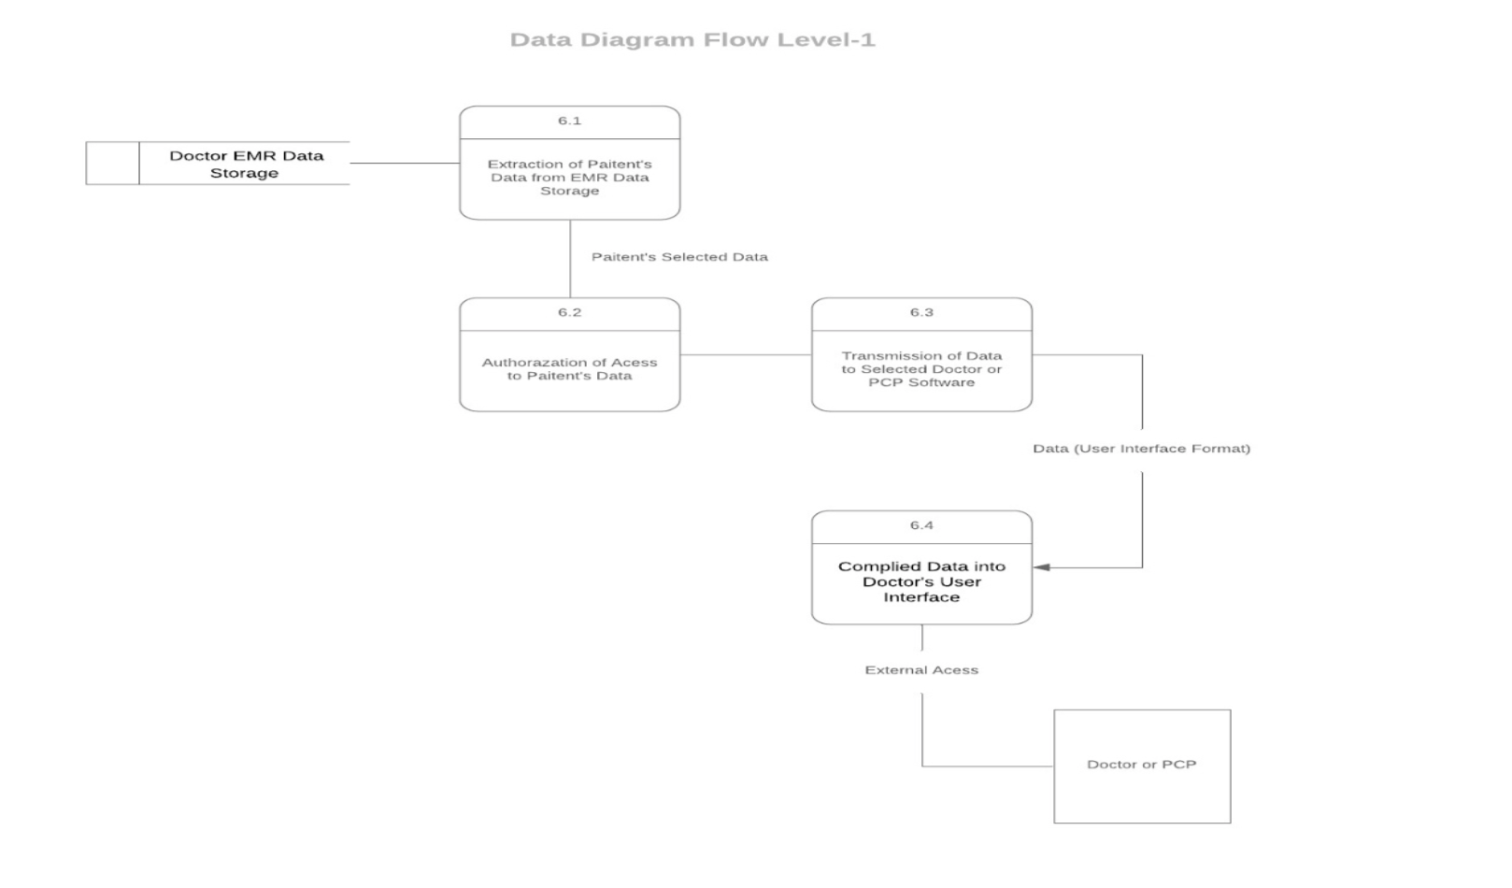

**Project Plan:**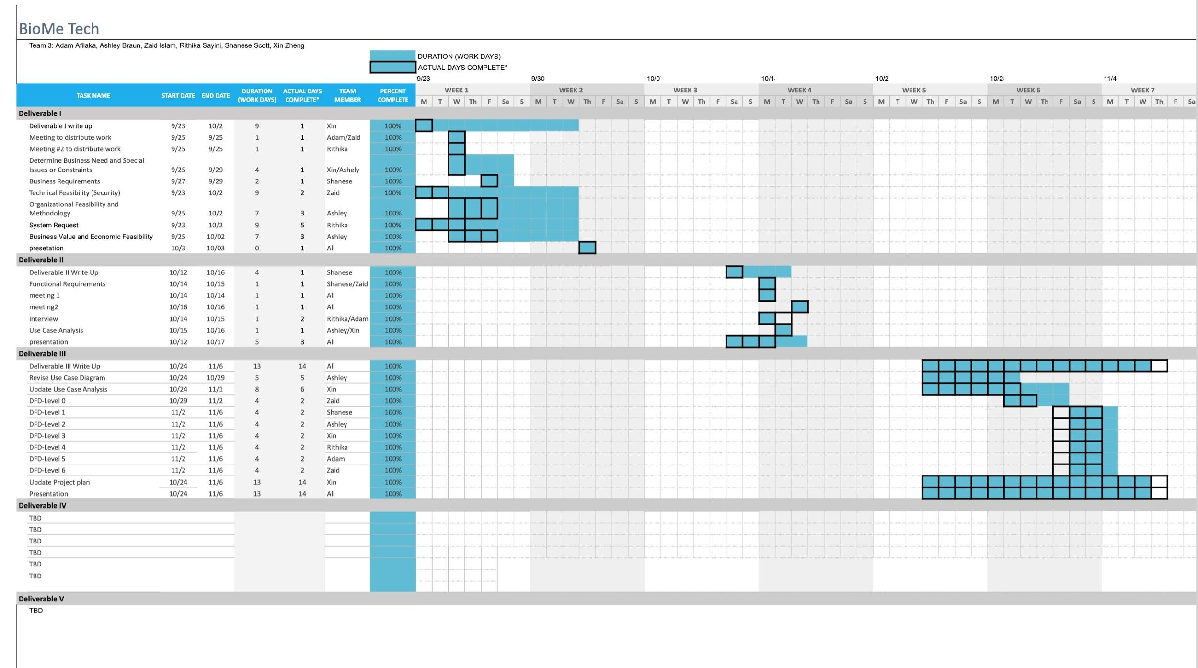

**Kanban Board:**

